BOOKING FORM FOR YOGA RETREAT IN GREECE with Billy Doyle

Hotel Delfinia, Molyvos, Isle of Lesvos 21 – 28 July 2018

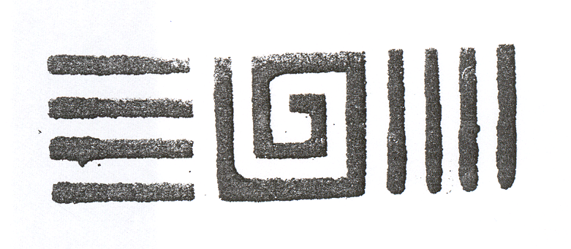

|  |  |
| --- | --- |
| NAME: |  |
| EMAIL: |  |
| MOBILE: |  |
| PHONE: |  |
| POSTAL ADDRESS: |  |
| *PAYMENT: |  |
| * *Please state whether it’s a deposit or full payment and if cheque or bank transfer.*  *Cheques payable to W Doyle* | |

* *Please indicate any medical conditions or injuries:*